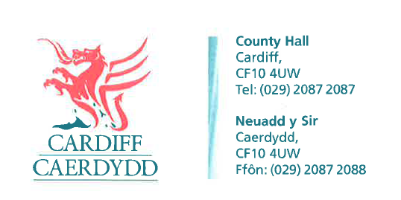
FOI Response Document
FOI12234 - Thank you for your request under the Freedom of Information Act 2000 about Team Structure Charts received on 17/08/2018:
Request/Response:
Please would you forward me the staffing structure (inclusive of names and full job titles) of your following departments;
• Council Tax (billing, collection, recovery and enforcement)
• Council Tax Reduction (assessment and awards)
• Housing Benefits (assessment, awards and overpayments)
• Discretionary Housing Payments (assessment and awards)
• Crisis Support (assessment and awards)
• Business Rates (billing, collection, recovery and enforcement)
• Business Improvement Districts (BIDs) (billing, collection, recovery and enforcement)
Please see attached documents which cover the organisation charts for the directorates detailed above.
Please can you also advise:
• What Revenue and Benefits Systems are used?
Cardiff Council use the “Northgate” billing system and “Civica W2 “ document management system.
• What the total spend on Temporary/Interim staff has been in the last twelve months
The total spend in the Revenue and Benefits Division was £180,000 for the last four financial quarters, (July 2017 to June 2018).
• Which/if any recruitment consultancies have been used to provide these staff
For the Revenues and Benefits Division, Cardiff Works Agency was used to provide the staff for Benefits Assessment, while Matrix SCM Ltd was used to provide the Revenue Services staff.
If you have any queries or concerns, please do not hesitate to contact us.

Please remember to quote the reference number above in any future communications.

